SaaS Funnel Analytics Report

1. Business Problem Statement
A SaaS product is experiencing inconsistent conversion across its acquisition funnel and an unusually high long‑term churn rate. The leadership team seeks a complete analytical framework that reveals where users drop off, what behaviors correlate with retention, and how many users are at risk of churn. The objective is to build an end‑to‑end analytics pipeline from data ingestion to modeling to funnel, retention, and churn insights to support data‑driven product and growth decisions.

2. System Architecture Overview
The system follows a clean multi‑layer architecture inspired by industry‑standard warehouse design patterns (RAW → STAGING → WAREHOUSE → ANALYTICS).
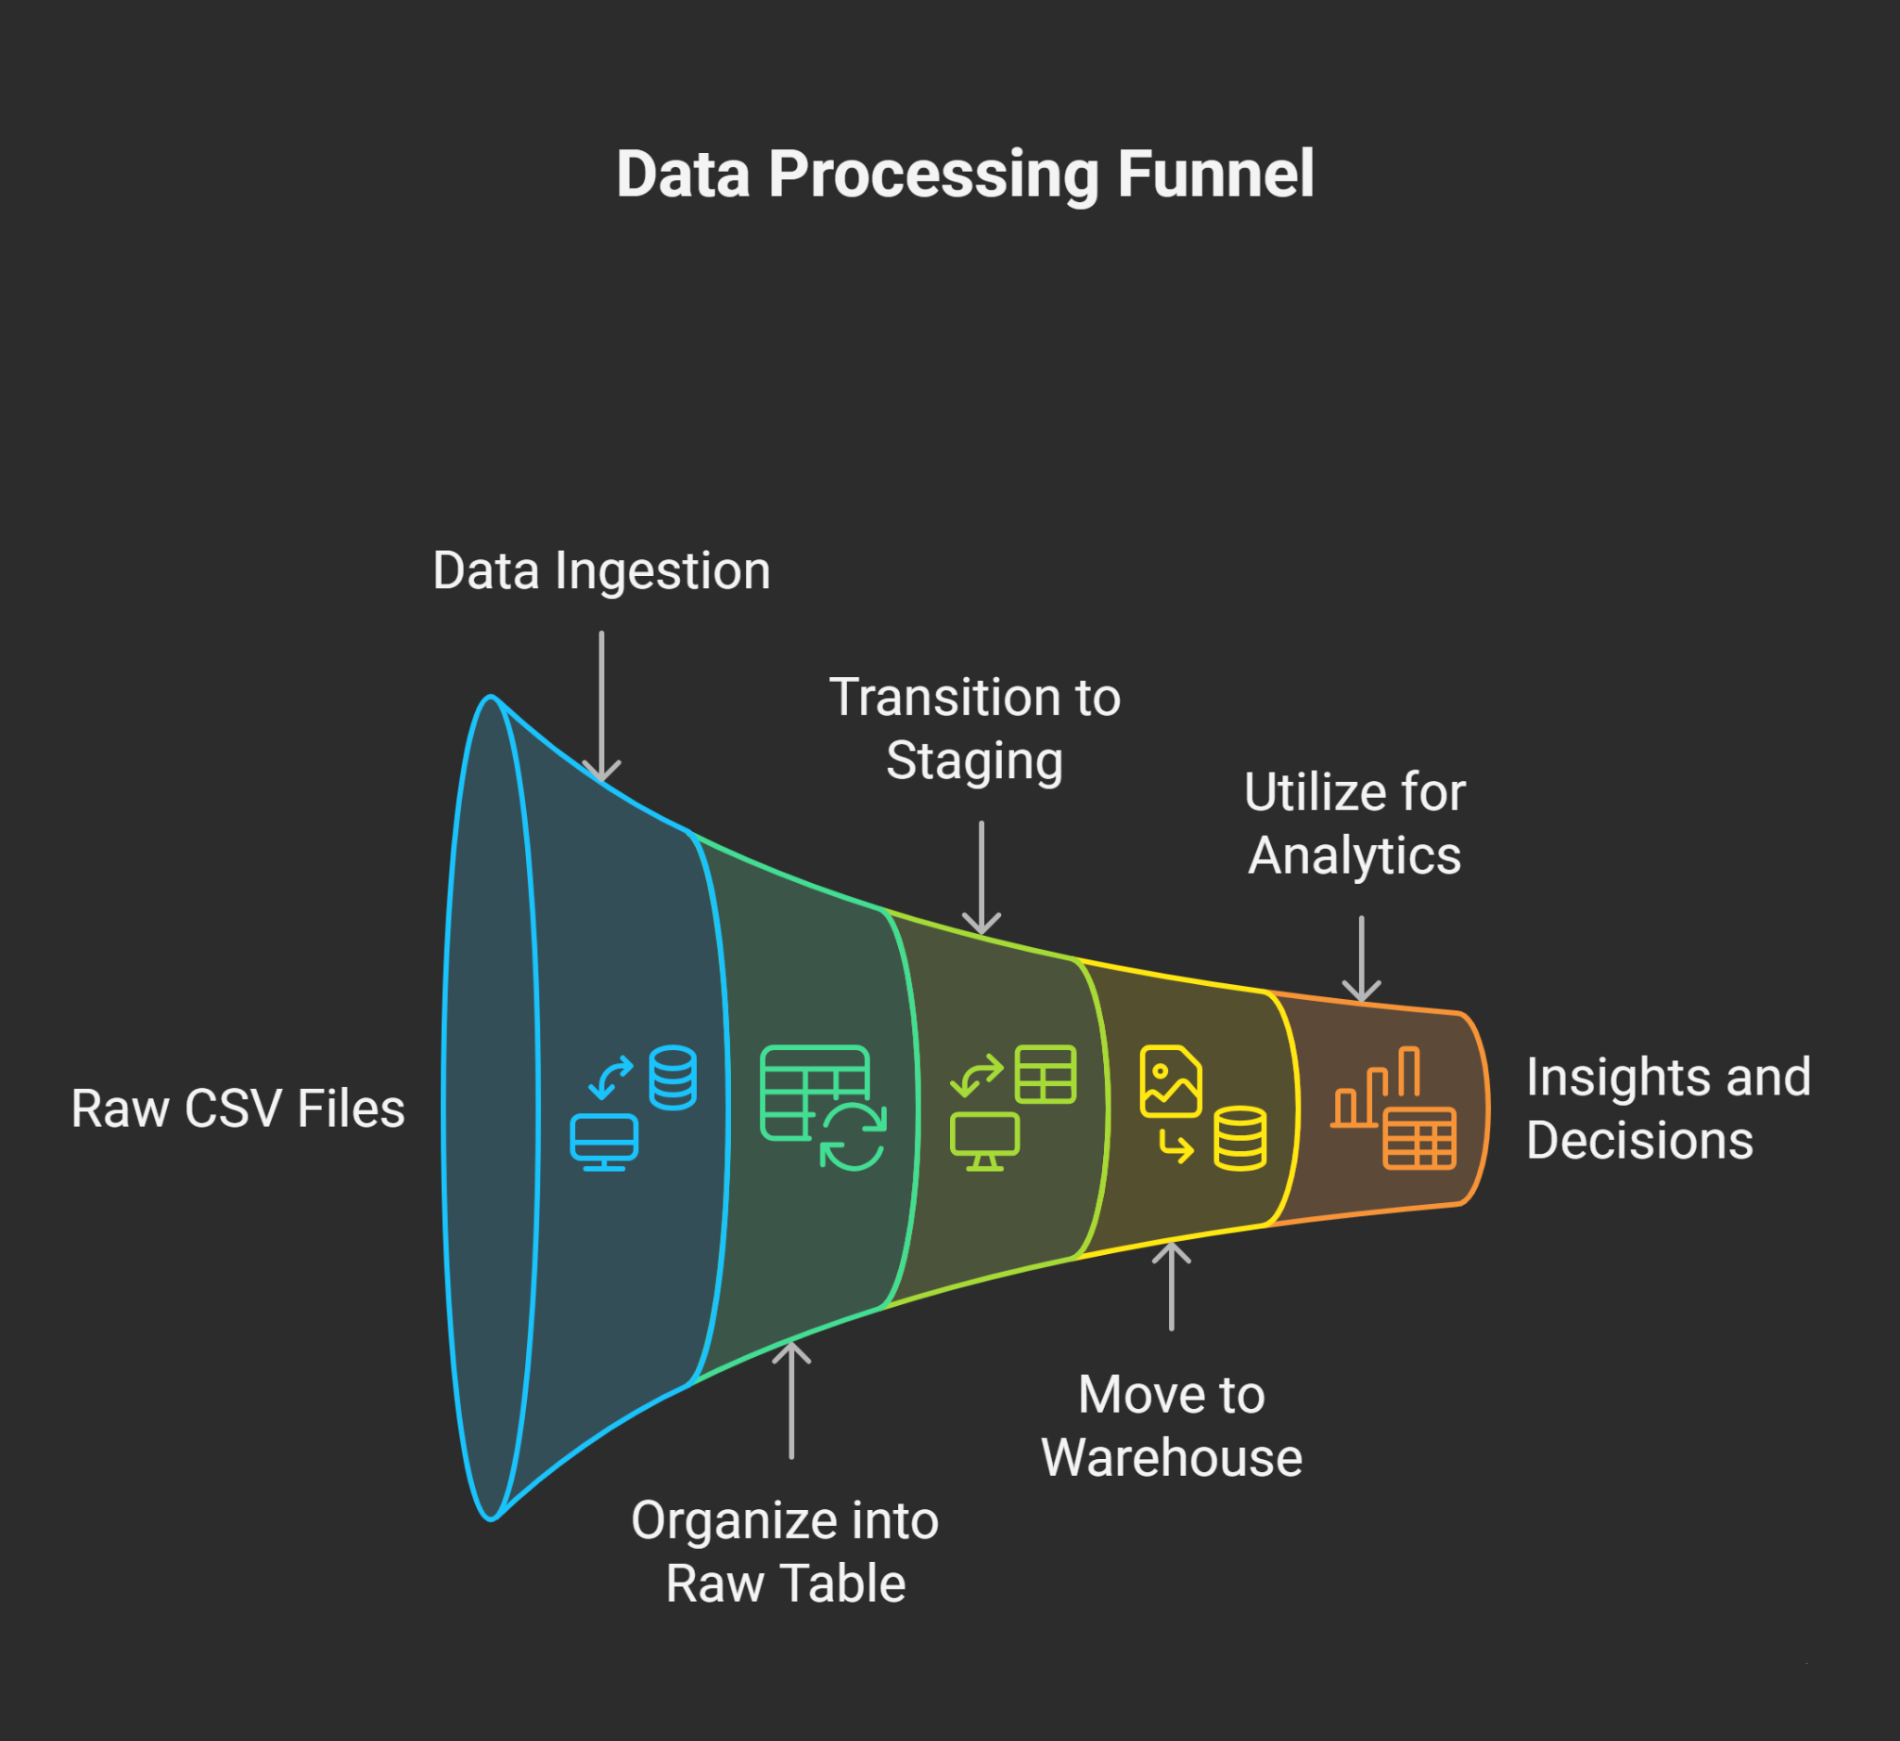

3. Dataset Overview & Summary Statistics
The analytics engine is built on a synthetic but realistic SaaS event‑stream dataset. The dataset simulates 5,000 users and ~58,000 timestamped events representing their journey through the product funnel.
Key characteristics:
• 5,000 unique users
• ~58,848 total events
• Events span ~2 months of simulated activity
• Includes acquisition, activation, engagement, subscription, and cancellation events

Event Types
The following events define the SaaS user lifecycle and are used throughout funnel, retention, and churn analysis:
• landing_page
• signup
• verify_email
• login
• start_trial
• feature_use
• subscribe
• cancel

4. Data Generation Logic Explanation
A Python script (`generate_events.py`) creates a full synthetic SaaS dataset. Although artificial, it accurately reflects user behavior patterns observed in real subscription products.

User Journey Simulation Logic
1. Each of the 5,000 users is randomly assigned a user persona:
• bounced
• signup_no_verify
• verified_no_trial
• trial_only
• subscriber_active
• subscriber_churn
2. Based on persona, the script generates event sequences in correct chronological order.
3. Additional engagement events (`feature_use`) are added for more active personas.
4. Timestamps progress naturally using random minute increments.
5. Each event is enriched with country, device_type, and plan_type where applicable.

Outcome
The result is a high‑fidelity event stream dataset suitable for advanced product analytics, funnel modeling, user segmentation, and lifecycle analysis.

5. ETL Pipeline (RAW → STAGING → WAREHOUSE)

RAW Layer
A raw table (`raw_events`) receives the CSV file ingested via Python. No transformations are applied at this stage. This keeps the source data immutable.

STAGING Layer
`stg_events` cleans and normalizes the data:
• trims and lowercases event names
• removes null user_ids
• enforces valid event types only
• converts timestamps to UTC
• standardizes device and country formats

WAREHOUSE Layer
Two analytical tables are modeled using standard dimensional modeling:
• `dim_users` — one row per user
• `fact_events` — one row per event (58,848 rows)
`fact_events` powers almost all funnel, retention, and churn analysis.

6. Funnel Analysis
The funnel quantifies how users progress from acquisition to monetization. The stages analyzed are:
• Landing Page → Signup
• Signup → Email Verification
• Verification → First Login
• Login → Trial Start
• Trial Start → Subscription
Using SQL window functions and step‑wise conversions, the analysis computes the number and percentage of users progressing through each stage.

Example Insights
• Significant drop‑off typically occurs between signup and email verification.
• A noticeable percentage of users initiate trials but never convert to paid subscriptions.
• Feature usage during trial strongly correlates with successful subscription conversion.

7. Retention Analysis
Retention is computed for D1, D7, and D30 cohorts using activity after signup. Each retention figure represents the % of users who returned to perform any activity after signup.

Retention Strength Observed
• D1 retention indicates immediate engagement quality.
• D7 retention reflects whether users integrate the product into weekly workflows.
• D30 retention is the gold standard for long-term product value.

8. Churn Analysis
Churn is defined as 30+ days of inactivity. A `user_last_activity` table determines each user's most recent event and labels them as churned or active.
The analysis produces:
• overall churn rate
• churn by signup cohort
• churn by device type

Churn Drivers Identified
• Users with low feature usage exhibit significantly higher churn.
• iOS and Android show slightly different churn behaviors.
• Early cohorts often churn faster due to lower activation rates.

9. Key Insights & Recommendations
1. Improve early‑stage onboarding — Verification is the biggest drop‑off point.
2. Strengthen trial activation — Feature usage is the strongest predictor of retention.
3. Reduce churn with lifecycle triggers — Users showing inactivity patterns should receive in‑app nudges.
4. Device‑specific improvements — Mobile users show higher churn and require optimized UX flows.

